

Detailed Level Design for Batch Jobs

File Archive / Backup

Change History:

Date | Version | Description | Updated by
06/24/2011 | 1.0 | Initial Draft | Cognizant
07/04/2011 | 1.1 | Updated with review comments | Cognizant

Approval Signatures:

Name | Title | Version | Date | Signature

TABLE OF CONTENTS
1. Overview 4
1.1. References 4
2. Use Case Details 5
2.1 Backup/Archive 5
3. Detailed Job Design 6
3.1 Job Properties 6
3.1.1.1. EDI_FileArchival 6
3.1.1.2. EDI_MonthlyScheduler 6
3.1.1.3. EDI_Adhoc Disk Space Scheduler 6
3.2 Job Parameters 7
4. Database Design 13
5. Clarifications 14
6. Open Issues 14

- Overview
This document covers the high level design for the introduction of new File Archival process incorporated into the system. This Script will be compress the existing EDI Files in the Multiple Backup Folders and transfer it to another server. The files that had been transferred will be purged from the existing server.
  - References
Serial No | Document | Version
 | EDI File Archive Backup Business_Requirement_Document_V3.0 | 3.0

- Use Case Details
2.1 Backup/Archive

Backup File Archival.

File Name starting with similar EDI transactions with Specific Date range would be archived together into a single file

In case of any archive failure, retry for the limit which is configured. Archive fails after the retry limit, send an email.

Log the archive status (success/failure) into table.

Archived files should be moved to an EDIArchive folder.

Archive file should be FTP-end to a destination.
In case of FTP failure, retry for the limit which is configured. FTP fails after the retry limit; send an email for manual download.

Log the FTP Status (Success/Failure) to table.

Monthly Scheduler Flag to be set as ‘No-run’ when Backup Archival script runs
.
As the script get completed set the flag as ‘Active’

EDI_MonthlyScheduler EDI_FileArchival
Monthly Scheduler Script

EDI_AdhocScheduler

Conditional Scheduler Script
- Checks the disk usage.
- Sends an alert mail to the user if the disk usage reaches Priority 2 and Priority 1 Threshold limits.
- Call the EDI_FileArchival Script
- For Priority 3 Threshold limits call the EDI_FileArchival Script.
- If the File Archival script works fine, display a message as “File Archival and FTP Successful”, else send alert mails to the user, as the frequency set for Priority 1 and Priority 2 issue.

- Detailed Job Design
3.1 Job Properties
      - EDI_FileArchival
Job Description | The job will be called for File Archival of the EDI Backup Files in multiple folders
Job Type | FTP
Job Parameterized | Parameter to be fed from Database
Job Frequency | Monthly, Daily
Job Predecessors | EDI_MonthlyScheduler & EDI_AdhocScheduler
Job Successors | N/A
Job Shared/Common | N/A
Job Process ID | Not yet assigned

      - EDI_MonthlyScheduler
Job Description | The job will call the EDI_FileArchival once in a month
Job Type | Monthly Scheduler
Job Parameterized | Parameter to be fed from Database
Job Frequency | Monthly
Job Predecessors | N/A
Job Successors | EDI_FileArchival
Job Shared/Common | N/A
Job Process ID | Not yet assigned

Job Description | The job will check the Disk Usage after every specified interval.
Job Type | Adhoc Scheduler
Job Parameterized | Parameter to be fed from Database
Job Frequency | Daily
Job Predecessors | N/A
Job Successors | EDI_FileArchival
Job Shared/Common | N/A
Job Process ID | Not yet assigned
      - EDI_Adhoc Disk Space Scheduler

3.2 Job Parameters

Parameter Name | Parameter Scope (Project/Job) | Parameter Data Type | Parameter Default Value | Parameter Description
Job Id | Job |  | 10001 | Job Id for this particular job
DB Server Name | Job |  | AMP5 | Database server name from property file
DB Server Name | Job |  | AMP9 | Database server name from property file
DB Schema Name for AMP5 Server | Job |  | CDPOLIB | Database server name from property file
DB Schema Name for AMP9 Server | Job |  | CSPDLIB. | Database server name from property file
DB Connection Url for AMP5 | Job |  | Given URL | Database server name from property file
DB Connection Url for AMP5 | Job |  | Given URL | Database server name from property file
DB User Id for AMP5 | Job |  | ymtest | Database server name from property file
DB Pwd for AMP5 | Job |  | ymtest | Database server name from property file
DB User Id for AMP9 | Job |  | VNDRPORT | Database server name from property file
DB User Id for AMP9 | Job |  | portal12 | Database server name from property file
No of Retry Frequency | Job | Number | 3 | If FTP fails, the no of retry mechanism
Priority No | Job | Number | 3 | Will determine the no. of priorities
Priority 3 Threshold limit | Job | Number | 75% | The Priority 3 Threshold limit
Priority 2 Threshold limit | Job | Number | 80% | The Priority 2 Threshold limit
Priority 1 Threshold limit | Job | Number | 90% | The Priority 1 Threshold limit
Email id of the recipient | Job | Varchar |  | The Email id of the recipient
FTP Server name | Job | Varchar |  | The Remote Server name
FTP User Id | Job | Varchar |  | The Remote Server User Id
FTP Pwd | Job | Varchar |  | The Remote Server Password
NOMHPI | Job | Number | 3 | No of mails if FTP fails in case of Priority 1 Issue
FOMHPI | Job | Number | 5min | Freq of mails if FTP fails in case of Priority 1 Issue
NOMMPI | Job | Number | 2 | No of mails if FTP fails in case of Priority 2 Issue
FOMMPI | Job | Number | 5min | Freq of mails if FTP fails in case of Priority 2 Issue
Flag | Job | Varchar | Active/No Run | The flag is set as per the flow of FTP job

3.1.1.3 Detailed Job Design Description

- Pre-Requisite for this Job

- Read the DB Server name, credentials, Schema name from the property file.
- Read the source parameters from the database, table (ED500P).
- There is a Root Folder would be created as /usr/local/<<EDIArchive>>
- Backup files under the following folder and all its subfolder would be considered for Archiving and Moving.
  - /usr/local/WagVP/trans/appl/fromWag
  - /usr/local/WagVP/trans/appl/toWag

- Archiving Procedure

- Files starting with similar EDI transactions(810,856 etc) will be archived together into a single archive file
- File Structure of the Archive File is fromWag_VP_<folder1>_.......<folder n>_<First Word of the Filename>_<DateRangFrom>_<DateRangeTo>
- Find the below examples:
  - File Names(echoback.d052010.t070126.rdy) Starting with echoback will be archived together into a single file as fromWag_VP_bkup_ echoback_0601_0615.tar.gz
  - FileName starting with VP.0180 ( VP.O180.D100202.T175400.RDY) will be archived together into a single file as fromWag_VP_bkup_VP.O180_0601_0615.tar.gz
  - FileNames starting with VP.0850 ( VP.O850.D100202.T175400.RDY) will be archived together into a single file as fromWag_VP_bkup_VP.0850_ 0615_0630.tar.gz
  - FileNames starting with VP.0861 ( VP.O861.D100202.T175400.RDY) will be archived together into a single file as fromWag_VP_bkup_VP.0861_0615_0630.tar.gz
  - FileNames starting with VP.861 ( VP.O850.D100202.T175400.RDY) will be archived together into a single file as fromWag_VP_bkup_VP.0850_0615_0630.tar.gz
  - File Names Starting with POASNInvoice (POASNInvoice_07-01-2009_0843.xml) will be archived together as a single file as fromWag_WM_bkup_POASNInvoice_0615_0630.tar.gz
  - File NameStarting with I856 (I856.VMAP.D090604.T160000.V033815.ASN00489512466CL.0000000000000000) will be archived together as a single archive file as toWag_bkup_errorfiles_I856_0615_0630.tar.gz
  - File Name starting with FilePolling would be archived together into a single archive file as toWag_bkup_filepolling_error_FilePolling_0615_0630.tar.gz
- In case of any failures while archiving, there should be retry mechanism and if retry fails, an email to be triggered to re-run the process.

- File Backup/Move

- FTP the files in the archive folder (for ex: EDIArchive) to the remote server.
- FTP Status whether it is a failure or success should be logged in the database.
- In case the moving fails, there are retry mechanism. No of retry frequency is store in the database.
- In case the moving fails even after retry, an email to be sent to the user for manual transfer.

- Disk Space Monitoring
- Another script is scheduled to check the disk usage in a defined interval, daily.
- If the disk usage reaches the Priority 3 threshold limit call the main script, set the flag as ‘no-run’. The ‘no-run’ flag stops the execution of the disk usage calculation script, while the file archival script is in progress. As soon as the File Archival script gets completed set the flag as ‘active’ and feed the control to the disk usage calculation script.
- If the disk usage reaches the Priority 2 Threshold Limit, send an alert mail; call the main script, set the flag as ‘no-run’. The ‘no-run’ flag stops the execution of the disk usage calculation script, while the file archival script is in progress. As soon as the File Archival script gets completed set the flag as ‘active’ and feed the control to the disk usage calculation script.
- If the disk usage reaches the Priority 1 Threshold Limit, send an alert mail call the main script, set the flag as ‘no-run’. The ‘no-run’ flag stops the execution of the disk calculation script, while the file archival script is in progress. As soon as the File Archival script gets completed set the flag as ‘active’ and feed the control to the disk usage calculation script.
- Once the FTP gets successfully completed it shows a message “File archival and FTP successful”.
- If FTP fails we are sending mail depending on the number and frequency as set for the Priority 1 and Priority 2 issues. As soon as the FTP is success the mailing stops with a success mail as “FTP successful”.

- FILE ARCHIVE FLOW
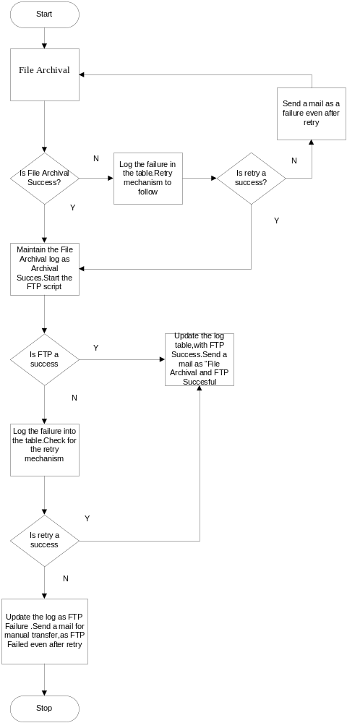

- Disk Usage Checking Flow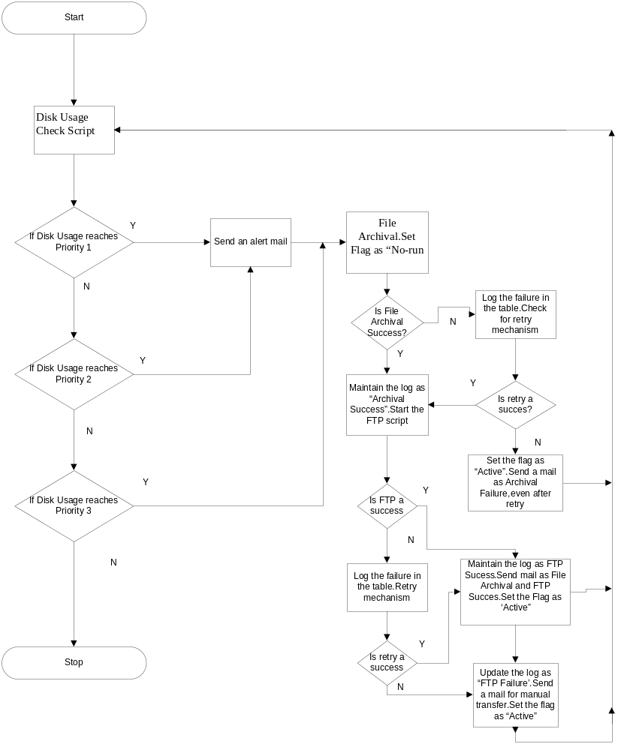

Reject/Error Handling

Reject/Error | File Description | Handling Instructions
FTP Failure | Automatic FTP fails | Retry mechanism, if retry fails, send mail for manual transfer
Archival Failure | File Archival fails | Retry mechanism, if retry fails, send mail, stating to re run the job
DB Server | Connectivity Issue with the Database Server | Retry mechanism, if retry fails, send mail, stating to re run the job

Additional Scripts

Script Name | Type of Script | Description
Monthly Scheduler Script | Unix Shell Script | Will call the main script monthly once
Disk Space usage Script | Unix Shell Script | Will check the disk usage and call the main script depending on the threshold limit.

- Database Design
- Table_Name =ED500P EDI Files Backup Source Parameters SQL Table

Column Name | Data type | Constraint (if any)
Parameter Key | VarChar[60] | Not Null
Parameter Value | VarChar[60] | Not Null

Parameter Key can have the following parameters and also any other parameters if required.
Job Id
No of Retry Frequency
Priority 3 Threshold limit
Priority 2 Threshold limit
Priority 1 Threshold limit
Email id of the recipient
FTP Server name
FTP User Id
FTP Password
NOMHPI
FOMHPI
NOMMPI
FOMMPI
Flag
Archive Folder Name

- Table_Name =ED501P EDI Files Archival & Transfer Log SQL Table

Column Name | Specification | Constraint(If Any) | Primary Key
Job Id | Number | Unique Key
Folder Name | Varchar[50] | Not null
Archive File Name | Varchar[50] | Not null
Files Date Range Start | Date | Not Null
Files Date Range End | Date | Not null
File Archival Status | Varchar[50] | Not null | File Name with path
File Archival Timestamp | Timestamp | Not null
FTP Status | Varchar[50]
FTP TimeStamp | Timestamp

- The DB server names, credentials and schema details should be in property files

- Clarifications

- Open Issues

